**Mole Maze**

Monty the Mole was looking at his mole mansion that he made underground and began to wonder about the different way he could add new rooms to his maze. If given the expansion plan to his mansion, do you think you can find the different ways to add rooms? You can only build ***one room*** at a time and you can travel freely between rooms you have ***already built*** only if they are ***connected***. You can choose to build ***any room*** as long as its ***previous room*** is already built.

**Input:** The first line of input contains **R** the number of rooms Monty will make. The next line contains **R** space-separated integers which are the previous rooms. Each integer **i** represents the number of that room (0-indexed). *previousroom*[**i**] represents the room that must be connected with **i**, so *previousroom*[**i**] must be built before **i**. For the 0th room, it will always be -1 since it’s already built.

**Output:** The different orders you can build the rooms in. The total amount of combinations will be very large so you will return (solution modulo (109 + 7)).

**Example Input:**

5

-1 0 0 1 2

**Example Output:**

6

**Explanation:** There are 6 different combinations. They are listed below. The original rooms are pictured below as well.

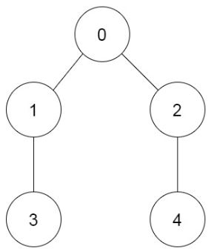0 -> 1 -> 3 -> 2 -> 4

0 -> 2 -> 4 -> 1 -> 3

0 -> 1 -> 2 -> 3 -> 4

0 -> 1 -> 2 -> 4 -> 3

0 -> 2 -> 1 -> 3 -> 4

0 -> 2 -> 1 -> 4 -> 3